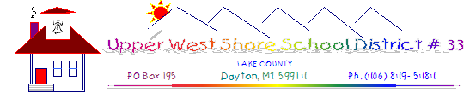

NOTICE OF TRUSTEE OPENINGS

UPPER WEST SHORE SCHOOL DISTRICT #33 WILL BE ELECTING ONE TRUSTEE FOR A THREE-YEAR (3) TERM ON MAY 3, 2022. INTERESTED CANDIDATES MUST FILE COMPLETED FORMS WITH THE DISTRICT CLERK BY 5:00 P.M. ON MARCH 24, 2022. PLEASE CONTACT BOARD CLERK DEB ANDERSON VIA EMAIL AT
danderson@daytonschool.net FOR CANDIDACY FORMS.

